
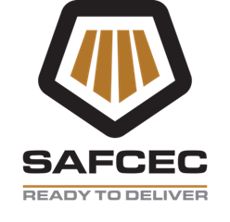


SAFCEC NEWSLETTER
March 2026

Bargaining Council News (BCCEI)

LABOUR COMPLIANCE BY SMALL SUBCONTRACTORS IS CRITICAL FOR SMOOTH PROJECTS

Labour compliance is essential to maintaining stability & fairness in the civils engineering sector, ensuring that all contractors & subcontractors operate on a level playing field & pay minimum wages as set out in the collective agreement.

With the right support from larger contractors & BCCEI, emerging businesses can meet these requirements & build sustainable, legally compliant operations.

According to Lindie Fourie, Operations Manager at the Bargaining Council for the Civil Engineering Industry (BCCEI), many emerging contractors lack the systems and administrative capacity required to manage labour compliance effectively and, in addition, may not fully understand the scope of their obligations. Read more: https:// bccei.co.za


LINDIE FOURIE
Operations Manager
New Membership

A special warm welcome to all our new members who joined SAFCEC recently. Should you require assistance or have any queries please contact your regional departments.

Industry News

Minister Macpherson

Rebuilding a capable state & Restoring
Accountability in Public Infrastructure.

Dean Macpherson`s feedback on construction infrastructure in S.A in 2026 includes a focus on accountability, digitization, & procurement reform. His plan, the South African Construction Action Plan (SACAP), aims to restore accountability, fixing falling projects, & end the circle of missed deadlines & mismanaged budgets. The plan includes a digitized, integrated Asset Information Management System & a Procurement War Room to enhance delivery and fiscal discipline.

Macpherson emphasizes the importance of learning from global practices, balancing new construction with maintenance, & ensuring that people are at the center of infrastructure initiatives. He also stresses the need for effective communication and long-term vision for sustainable infrastructure development expedite economic growth & creating employment.
Read more: Full Speech http://www.publicworks.co.za

Minister Dean Macpherson

Infrastructure South Africa (ISA)

The feedback on Infrastructure South Africa (ISA) in 2026 indicates a strong commitment to infrastructure development & investment in S.A. The governments focus on stabilizing debt, accelerating public investment, & reforming the infrastructure sector is evident.

The allocation of R1 trillion for infrastructure projects is a significant step towards enhancing the country`s infrastructure capabilities. The formalization of the ISA through legislation is expected to further streamline project preparations and coordination, ensuring that more projects are successfully implemented & attracting increased investment.

The Minister of Public Works & Infrastructure has welcomed the scale of infrastructure allocations in the national budget, particularly in transport, logistics, water & energy, as a clear opportunity to.
Read more: https://infrastructure.org

CONSTRUCTION MAFIA

The Construction Industry Development Board (CIDB) warns that the construction mafia is down, but it is not out.

On Monday, CIDB Chief Executive Officer, Bongani Dlada said although the group has been severely neutralized, it is not yet completely eliminated. He attributed that massive reduction of site disruptions & stoppages to the 2024 National Construction Summit in Durban which concluded with a declaration to form a joint multi-stakeholder approach, including better data collection, whistleblower reporting mechanisms & faster enforcement actions.

“The construction mafia has not disappeared, but the coordinated response by government and industry has made a measurable impact. We have seen a drastic reduction in site disruptions and stoppages in a number of areas, which points to progress rather than the total elimination of the problem. Read more: themercury.coz.za
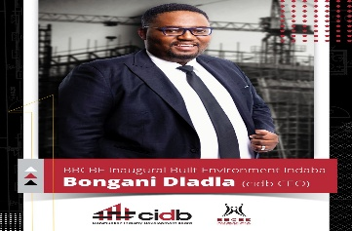
KZN Department of Public Works

The KZN Head vows to tackle contractor delays and enforce accountability.
Dr Vish Govender has declared stalled a thing of the past & promised harsh steps against non-compliant officials &
contractors.

The meetings held recently brought together industry leaders, grade 8 & 9 contractors, the head of infrastructure, the chief director for infrastructure, program managers, engineers, electrical engineers, mechanical engineers & civil engineers.
Read more: https://iol.co.za/news/south-africa/kwazulu-natal/
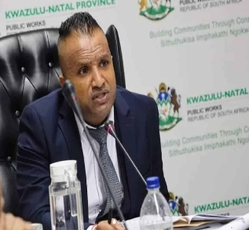 Dr Vish Govender
2026 Meeting Held

The Northern Regional
National Annual General Meeting was held on the 26.02.2026.
North Branch MANCO was held on the 17.03.2026.

Upcoming Meetings

North Branch – Branch Meetings
29.05.2026

Meeting Invites

SAFCEC was invited to the Department of Small Business Development. The invitation was to assist with more information on infrastructure development from an engineering perspective.

The workshop was held on the 17 -18 March 2026, Topic of discussion with the various sectors of the economy whom attended were on, One National Plan Concept for the MSMES Ecosystem.

The Workshop was successfully attended with more than 200 guests per day. Items of discussion and strategy plans discussed and put forward to the Deputy Director General (D.D.G) Team.
Tenders Awards

To the members that have been awarded tenders congratulations on this great achievement.



SAFCEC Website

Check out the SAFCEC Website for latest uploaded tenders: https://safcec.org.za

SHERQ
Safety, Health, Environment, Risk & Quality

Legislative updates

Amendments to the COID Act have been communicated and members are encouraged to familiarize themselves with the changes affecting injured employees.
The regulatory landscape continues to evolve, and we remain committed to keeping our members informed.
SAFCEC is actively engaging with SACPCMP to ensure that industry voices are heard.

Construction Incidents

The tragic Ormonde incident, where nine workers lost their lives, is a sobering reminder of the stakes in our industry. Every life lost is one too many.
We honour those affected by recommitting ourselves to prevention, accountability, and care-in-action.
Rigorous pre-task planning and hazard identification remain non-negotiable.

Mental Wellness Awareness

Safety is not only physical — it is also mental. Stress, fatigue, and burnout undermine performance and increase risk. This month we highlight Mental Wellness Awareness, encouraging members to foster supportive environments where workers feel valued and resilient.
Member Benefits

We are pleased to introduce SAFCEC-branded license disc stickers for our members. Beyond being practical, they serve as a visible badge of belonging to a community that prioritizes safety, quality, and collaboration.



